The Major Arcana
The Major Arcana is a 22-card set within the tarot that is the core and the foundation for the deck. All the deck is filled with archetypal significance, but this is most pronounced within the Major Arcana. These cards follow a storyline that tells of the spiritual travels taken from the innocent wonder of The Fool to the oneness and fulfilment of The World. In other words, these cards tell the story of humanity's spiritual evolution into enlightenment. The Major Arcana are like big signposts to the major issues relating to the person being read. They show the challenges and means of change available. The Major Arcana cards often have double meanings to them, and the interpretation will depend on the adjacent cards and the intuitional feeling of the reader. I have included the double meaning where necessary:

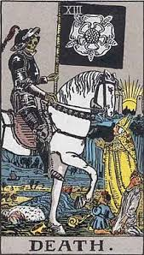
Death
Rarely means physical Death – more the ending of a situation, the end of a cycle and new beginnings – it is a good card!
Change, transformation and transition.
Reversed = resistance to change and delays.

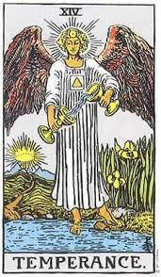
Temperance – Double meaning attached.
Balance, moderation, patience purpose.
Person needs to obtain their own identity, may a have a controlling partner.
Reversed: Imbalance, excess and lack of long-term vision.

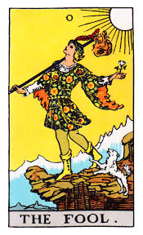
The Fool – Double meaning card.
Innocence, naivety needs to take a leap of faith – a free spirit.
Debt and financial issues, living beyond means.
Warning card if signing contracts or investing – read the small print.
Reversed: Recklessness, risk taking.

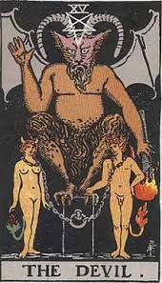
The Devil – Double meaning card.
Can mean feeling bound to a situation person, jealousy, addiction and materialistic. Someone around cheating or feeling cheated.
Also, can mean a soul mate – very strong love bond – major relationship signpost card.
Reversed: Detachment breaking free and reclaiming power.

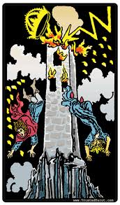
Tower – double meaning card.
Bolt from the blue card – disaster, upheaval, sudden and unexpected change or revelation.
Can also mean the purchasing property, house or business. Everything needs knocking to the ground and rebuilding again.
Reversed: Avoidance of disaster, fear of change.

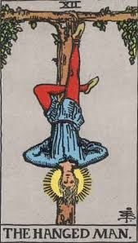
The Hanged Man:
Restriction, being in limbo – inaction card, sacrifices made and the need to let go.
Also, the lazy card – lack of motivation. Own worst enemy.
Reversed: Feel like a martyr, indecision and delay.

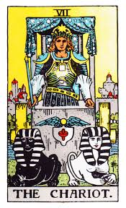
Chariot: Major communication card.
Moving forward quickly, travel, victory and determination. Needs to work on their communication in a relationship, needs to be more communicative about their needs and wants, needs to open more.
Reversed: Lack of control and direction, aggression.

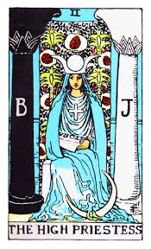
The High Priestess: Double meaning card.
Intuition, subconscious mind, higher power. Creative person and needs to use their creativity more. Good news to come around marriage and birth.
Reversed: Feeling powerless. Hidden agendas, secretive and needs to listen to intuition more.

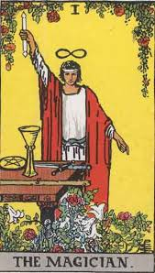
Magician – Major Spiritual and Clairvoyance Card.
Very positive. Powers skill and concentrated action. Resourcefulness. Manifestation card.
Reversed: Manipulation, poor planning, lapsed skills and talents.

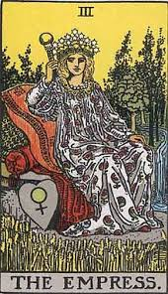
Empress – Learning card.
Fertility card - ideas and physically. Femininity, abundance and female power. A thirst for knowledge, studying, training and wanting new avenues to explore.
Reversed: Creative blocks, dependence on others. Lacking in power.

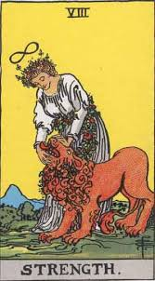
Strength:
Courage, compassion, patience, control, have strength but may doubt it. May need to be stronger – it is present and needs to start using it more.
Reversed: Weakness, self-doubt, lack of self-discipline.

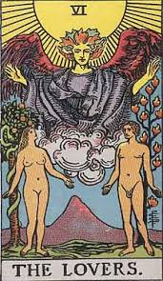
The Lovers: Double meaning card.
Love, union, relationships, values, new relationship or recharging of an existing one. Compatibility and shared values.
Reversed - May need renewed passion for career or relationship.

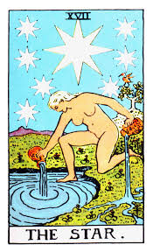
The Star – Double meaning Card - Good luck for one year.
Hope, spirituality, renewal, inspiration and serenity. Pregnancy – planned or unplanned.
Reversed: Lack of faith, despair and discouraged.

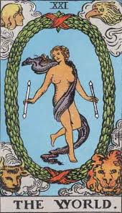
The World: Double meaning. Major travel card.
Travel opportunities, completion, integration, accomplishment – “the World’s your oyster.” Needs to let the past go and move on.
Reversed: Lack of completion, lack of closure.

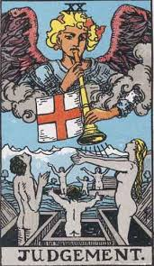
Judgement: Major Card.
Judgement, rebirth, inner calling and absolution. May have issues in all areas of their life and needs to sort everything out.
Reversed: Self-doubt, refusal to look inwards.

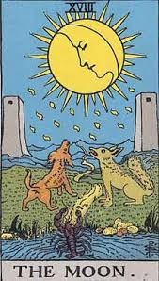
The Moon – Good luck one year.
Trusting intuition and dreams. Feminine energy and power. The light at the end of a long tunnel.
Reversed – Release of fear, confusion and unhappiness – possibly not sleeping.

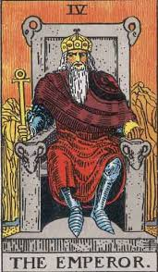
The Emperor – Major self-employment card.
Authority, control, Father figure, structure and foundations. Needs to aim high, take opportunities presented. Get what you want.
Reversed: Domination, inflexibility, rigid control.

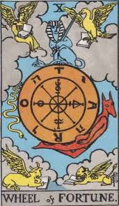
Wheel of Fortune: Double meaning card.
Good luck, Karma, life cycles, destiny and a turning point. Happiness and contentment or need to take action to help themselves and move forward.
Reversed: Bad luck, negative external influences, out of control.

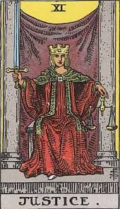
Justice: Double meaning Card.
Justice, fairness, truth, cause and effect and matters relating to the Law and Courts. Life not in balance.
Reversed: Unfairness, dishonesty and lack of accountability.

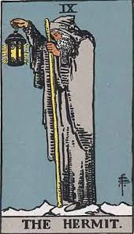
Hermit – Can indicate Depression card.
Soul searching, introspection, needing alone time, inner guidance.
Reversed: Isolation, loneliness, withdrawal, poor mental health.

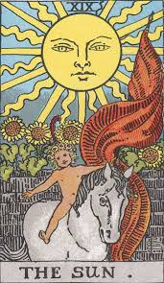
The Sun – Good luck for one year.
Warmth, success, positivity, vitality and energy, children and family card – news of a birth – planned.
Reversed: Temporary depression, lack of success – short term.

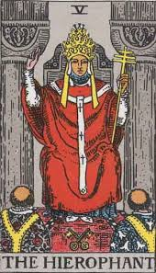
The Hierophant:
Traditions, beliefs, stability and increased finances. Positive card.
Reversed: Restriction and control, challenging the status quo.

